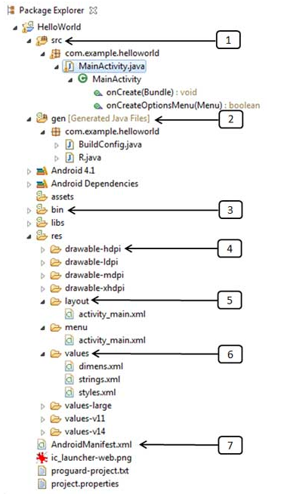

<http://www.ntu.edu.sg/home/ehchua/programming/android/Android_HowTo.html>

<http://www.herongyang.com/Android/Project-Android-Project-Folder-Structure.html>

http://www.compiletimeerror.com/2013/01/directorystructure-of-android-project.html